**Test Case 0008**

**System:** Bench

**Description:** Tests that the user is able to view my event calendar

**Severity**: 3

**Instructions**

**Test 1**

1. Start the Bench application.
2. Click the button “Login” on the navigation bar.
3. Enter the email “team23project@gmail.com” into the text field labeled “Email address”.
4. Enter the password “12345678” into the field labeled “Password”.
5. Click the button “Login” below the field.
6. Open the event calendar using the My Event button on the navigation bar

**Expected Result:** The user should be directed to a page with the team23project review page

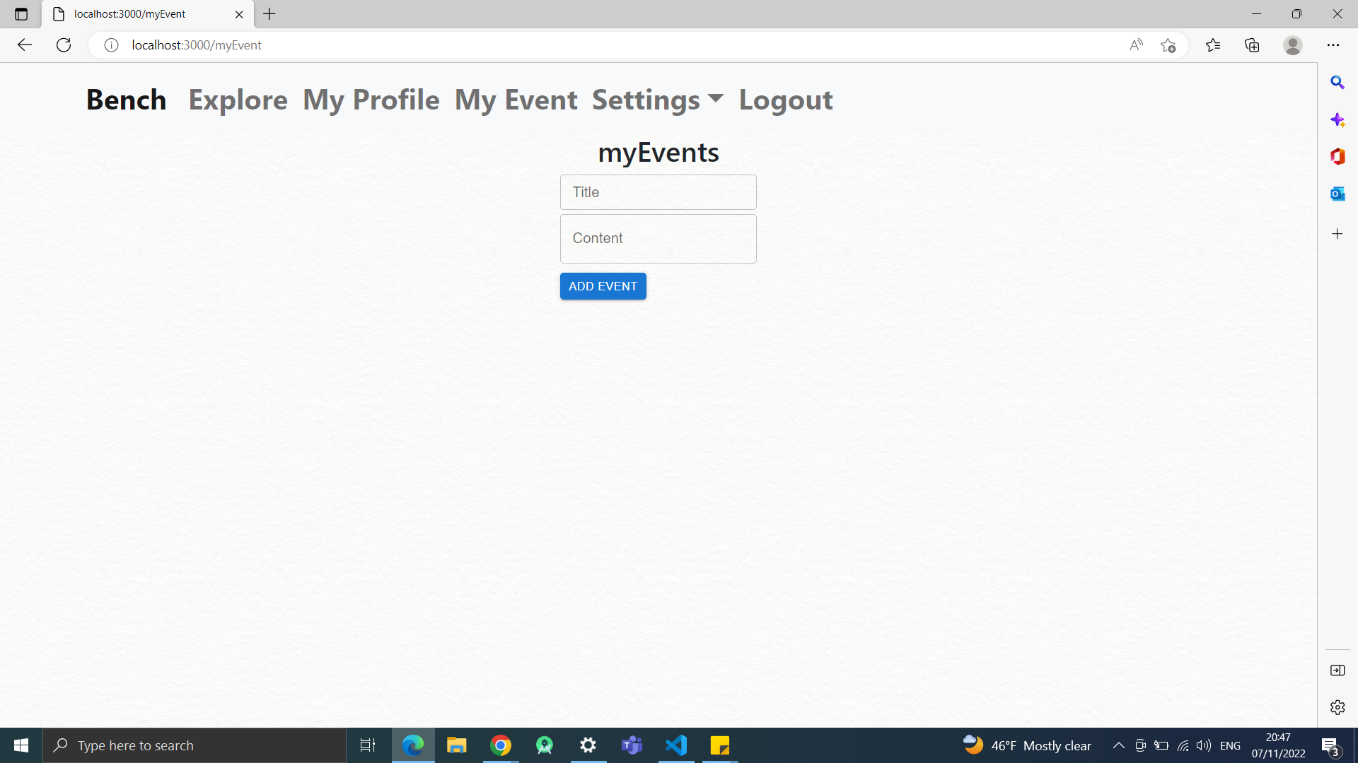

**Test 2**

1. Start the Bench application.
2. Click the button “Login” on the navigation bar.
3. Enter the email “team23project@gmail.com” into the text field labeled “Email address”.
4. Enter the password “12345678” into the field labeled “Password”.
5. Click the button “Login” below the field.
6. Open the event calendar using the My Event button on the navigation bar
7. Press the button that looks like a pencil on one of the events.
8. Enter “event” on the title field, and the current date on the content field
9. Press the “CHANGE EVENT” button

**Expected Result:** The user should be able to change an existing event’s details.

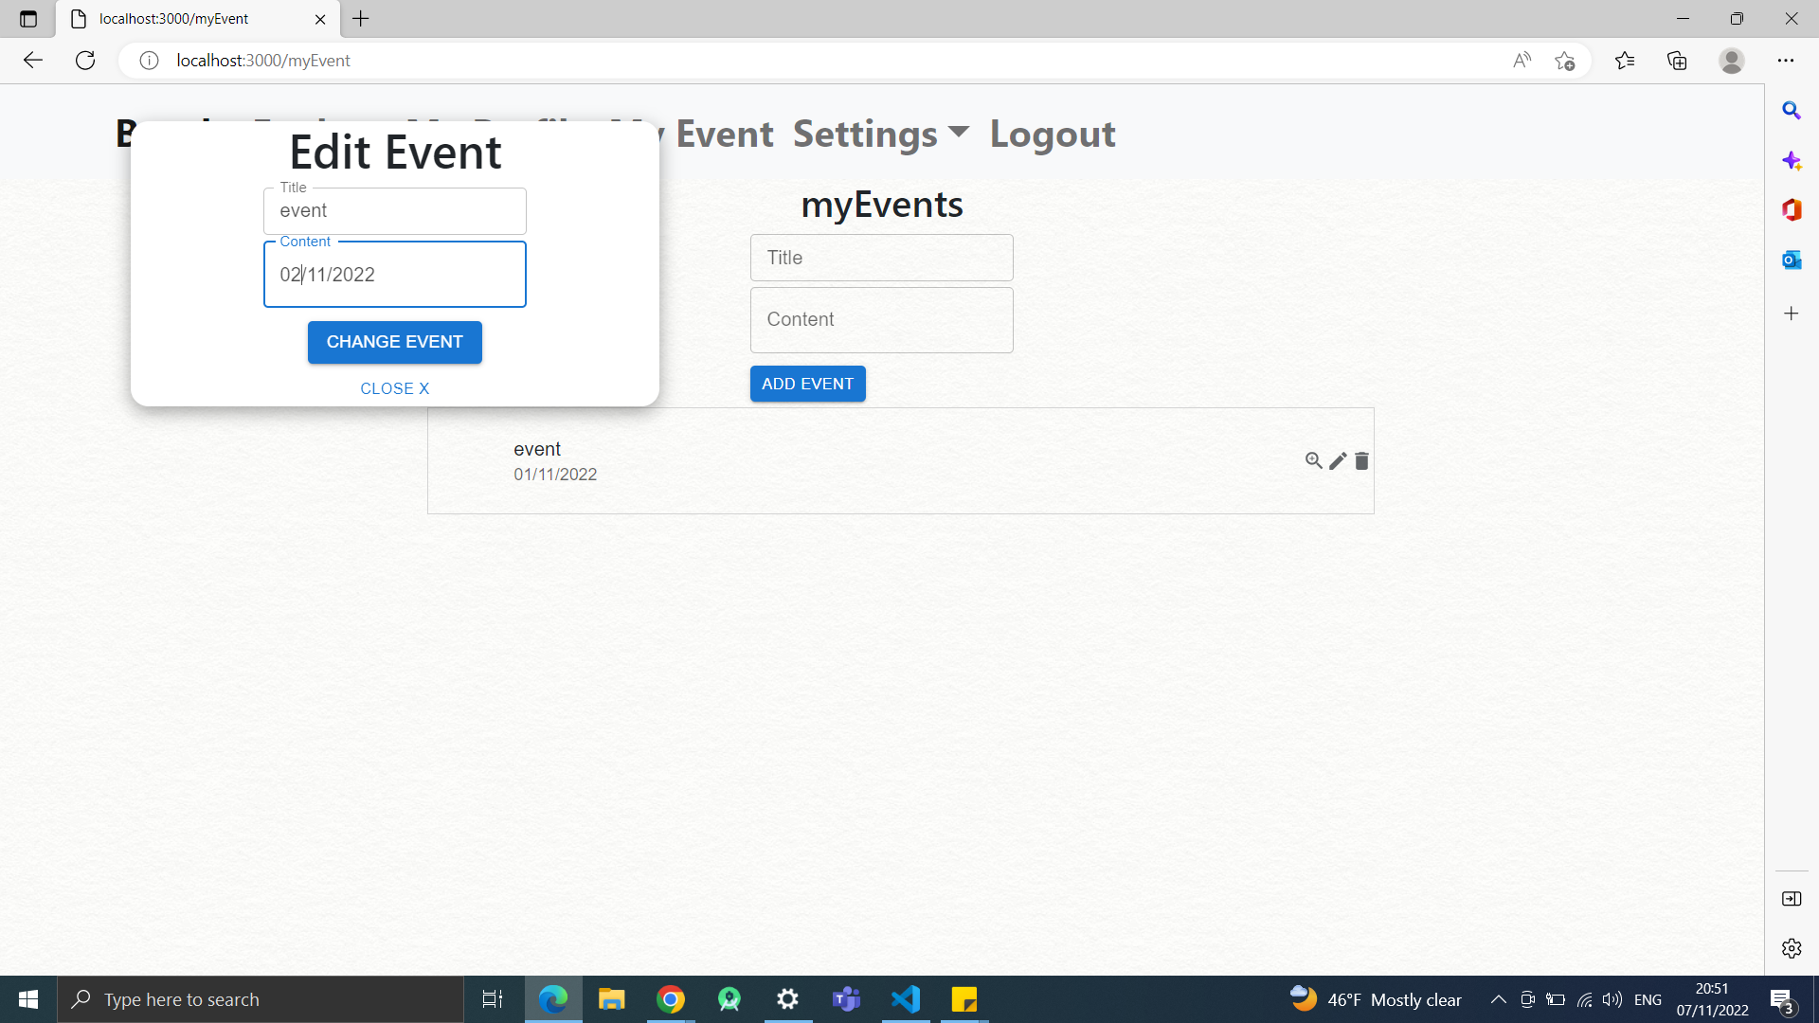

**Test 3**

1. Start the Bench application.
2. Click the button “Login” on the navigation bar.
3. Enter the email “team23project@gmail.com” into the text field labeled “Email address”.
4. Enter the password “12345678” into the field labeled “Password”.
5. Click the button “Login” below the field.
6. Open the event calendar using the My Event button on the navigation bar.
7. Press the button that looks like a magnifying glass on one of the events.

**Expected Result:** A pop up will appear showing the details of the event

